# **Data 604 –ER and Relational Model**

|  |  |  |  |  |  |
| --- | --- | --- | --- | --- | --- |
| Entities | Relationships | | Entity Type | Cardinality in words | cardinality |
| City | Each city in the County has one team that represents it | Concrete | | Upper bound: One team implies one  Lower bound: “Each” implies one | One and only one |
| County | Inference: Each County has many cities | Concrete | | Upper bound: “Each” implies one  Lower bound: “Many” implies Many 😉 | One to Many |
| Team | Each team has a maximum of 12 players and a minimum of 9 players. | Abstract | | Upper bound: 12 (Many)  Lower bound: “Each” implies one | One to Many |
| Player | Inference: Each player plays for one team | Concrete | | Upper bound: “Each” implies one  Lower bound: “One” implies one 😉 | One and only one |
| Plays (Associate) | Each team plays two games (home and visitor) against each of the other teams during the season. | Abstract | | Upper bound: “Plays” is plural hence > 1 implies Many  Lower bound: “Plays” is plural hence > 1 implies Many | Many to Many |
| Coach | Each team also has up to three coaches. | Concrete | | Upper bound: “Each” implies one  Lower bound: “Up to 3” many  Inference: Each coach coaches one | One to Many  Reverse (One to One) |

## Princeton County Basketball Conference

## Princeton County Basketball Conference ERD

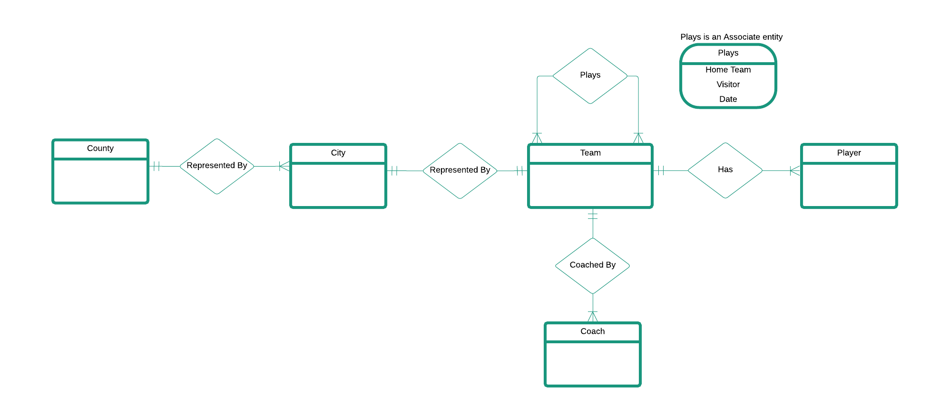

## Princeton County Basketball Conference Relational Model

County(**County ID**, County Name)

City(**City ID**, City Name, *County ID*)

Team(**Team ID**, Team Name, *City ID*)

Plays(*Home Team ID, Visitor* *Team ID*, Date)

Player(**Player ID**, *Team ID*, Player Name)

Coach(**Coach ID**, *Team ID*, Coach Name)